**SIVA SIVANI DEGREE COLLEGE-KOMPALLY**

**(AUTONOMOUS)**

**FACULTY OF SCIENCE**

**MATLAB RECORD**

**CLASS: B.Sc.- Iyr MSCs.-I Sem**

1. **Arithmetic operations with scalars**

|  |  |
| --- | --- |
| Operation | Symbol |
| Addition  Subtraction  Multiplication  Division  Powers | +  -  *  /  ^ |

The most common arithmetic operations in MATLAB are

1. **Aim:** Write a program for addition, subtraction, multiplication, right division, left division, Exponentiation of scalars.

**Program:**

1. **Addition**

>> a = 5;

>> b = 3;

>> result = a + b;

>>disp(result);

**Output:**

8

1. **Subtraction**

>> a = 5;

>> b = 3;

>> result = a - b;

>>disp(result);

**Output:**

2

1. **Multiplication**

>> a = 5;

>> b = 3;

>> result = a * b;

>>disp(result);

**Output:**

15

1. **Right Division**

>> a = 5;

>> b = 3;

>> result = a / b;

>>disp(result);

**Output:**

1.6667

**e) Left division**

>> a = 5;

>> b = 3;

>> result = a \ b;

>>disp(result);

**Output:**

0.6000

**f) Exponential**

>> a = 5;

>> b = 3;

>> result = a ^ b;

>>disp(result);

**Output:**

125

**g)Combined operations**

>> a = 5;

>> b = 3;

>>c = 7;

>> result = (a + b) * c - (b / c) + a^2;

>>disp(result);

**Output:**

80.5714

1. **Elementary Math built in functions**

|  |  |
| --- | --- |
| sin(x), asin | Sine and inverse (argument in radians) |
| sind(x), asind | Sine and inverse (argument in degrees) |
| sinh(x), asinh | Hyperbolic sine and inverse (arg. in radians) |
| Analogous for the other trigonometric functions: cos, tan, csc, sec, and cot |  |
| abs(x) | Absolute value of x, complex magnitude |
| exp(x) | Exponential of x |
| sqrt(x), nthroot(x,n) | Square root, real nth root of real numbers |
| log(x) | Natural logarithm of x |
| log2(x), log10 | Logarithm with base 2 and 10, respectively |
| factorial(n) | Factorial of n |
| sign(x) | Sign of x |
| mod(x,d) | Remainder after division (modulo) |
| ceil(x), fix, floor | Round toward +inf, 0, -inf |
| round(x) | Round to nearest decimal or integer |

**Aim:** Write a program for calculating square root , nth root, factorial, exponential, logarithmic values

**Program:**

>>factorial(5)

**Output:**

120

>>sqrt(81)

**Output:**

9

>>nthroot(8,3)

**Output:**

2

>>exp(2)

**Output:**

7.3891

>>log(5)

**Output:**

1.6094

>>log10(3)

**Output:**

0.4771

1. **Defining variables and constants.**

**Aim:** Write a program for defining variables and constants

**Program:**

>>x=15;

>>x=

**Output:**

15

>>x=3*x-12;

>>x=

**Output:**

33

>>pi

**Output:**

3-1416

>>i

**Output:**

0.0000+1.0000i

>>1/0

**Output:**

inf

1. **Graphical interpretation of a function with two variables.**

**Aim:** Write a program to graphical interpretation of a function with two variables by using MATLAB.

**Program:**

>>x = [-10:.1:10];

>>y = [-10:.1:10];

>>plot3(x, y, x.^2 + 3*y)

>>grid on

**Output:**

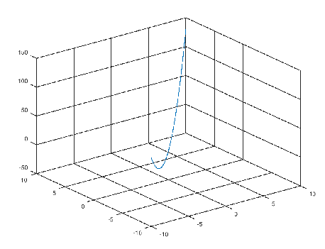

1. **Basic statements of two dimensional graphs representation.**

**Aim:** Write a program to two dimensional graph y=x by using MATLAB.

**Program:**

>> x=0:1:10;

>> y=x;

>> plot(x,y)

**Output:**

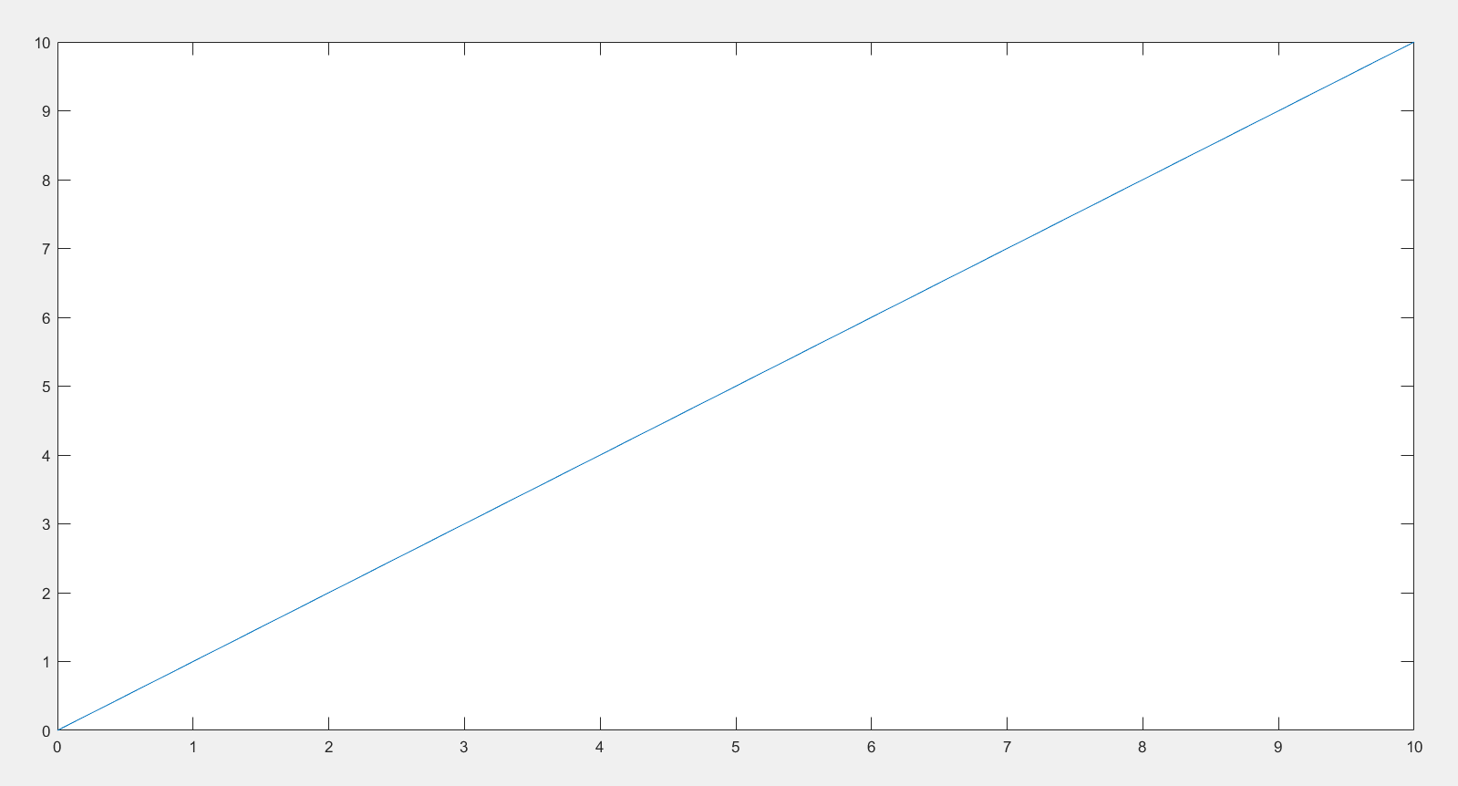

1. **Basic statements of two dimensional graphs representation.**

**Aim:** To Write a program to two dimensional graph by using MATLAB.

**Program:**

>>x = [-10:.1:10];

>>y = [-10:.1:10];

>>[xx, yy] = meshgrid (x, y);

>>z = xx.^2 + 3*yy;

>>mesh(x, y, z)

>>meshc(xx,yy,z)

>>xlabel ("x");

>>ylabel ("y");

>>zlabel ("f(x,y)");

>>title ("f(x,y) = x^2 + 3y");

>>grid on

**Output:**

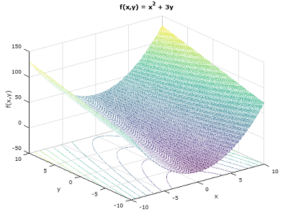

1. **Plotting three dimensional surfaces.**

**Aim:** Write a program to plotting three dimensional surfaces

By using MATLAB.

**Program:**

>> x=-3:0.1:3;

>> y=x;

>> [x1,y1]=meshgrid(x,y);

>> z1 = x1.^2+y1.^2;

>> surf(x1,y1,z1)

**Output:**

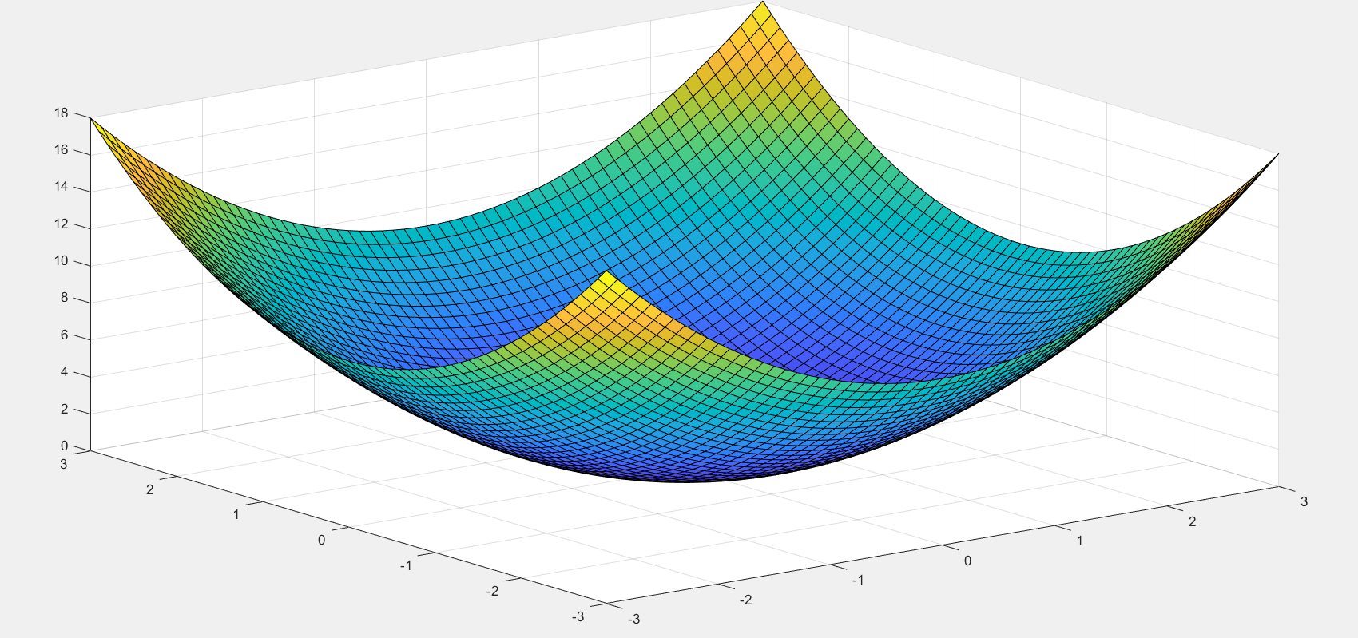

1. **Graphical Interpretation of a function with two variables**

**Aim:** Write a program to graphical interpretation of a function with two variables by using MATLAB.

**Program:**

>> [x,y]=meshgrid(-4:1:4,-4:1:4);

>> z = x.^3 + y.^3;

>> mesh(x,y,z)

**Output:**

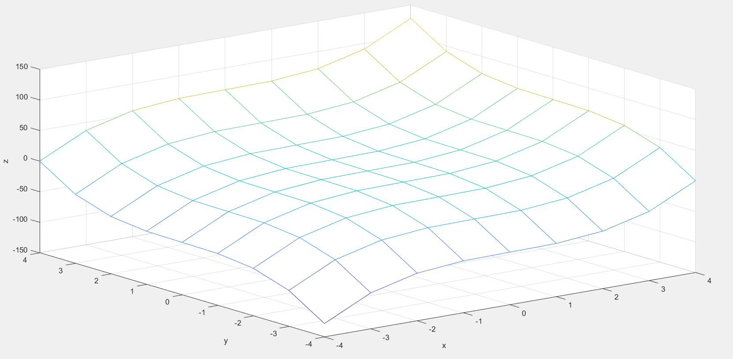

1. **Formatting a two dimensional plots by using MATLAB.**

**Aim:** Write a program to plot  and  by using MATLAB

**Program:**

>> x=0:1:10;

>> y1 = x;

>> y2 = x.^2;

>> plot(x, y1, 'b--', 'linewidth', 2);

>> hold on;

>> plot(x, y2, 'r-o', 'linewidth', 1.5);

**Output:**

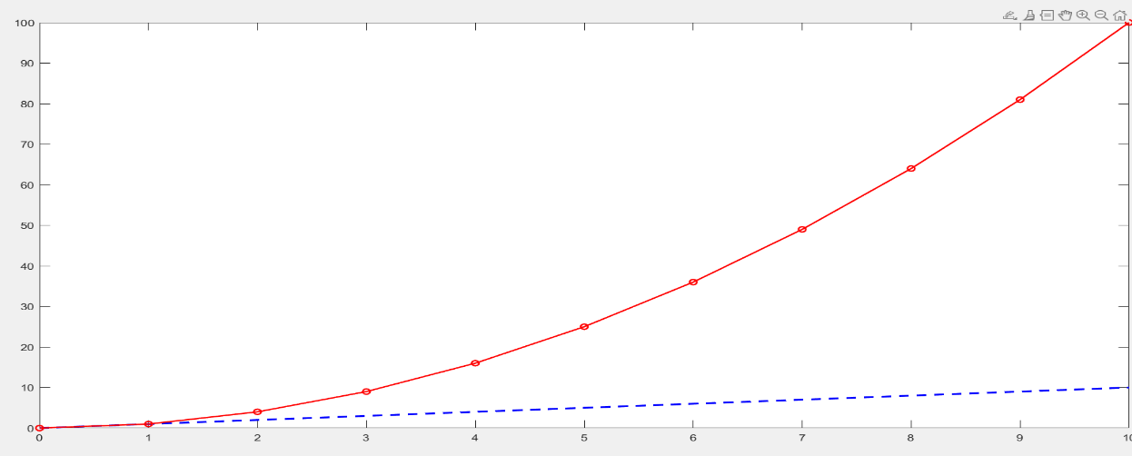

1. **Problem on two dimensional graphs representation.**

**Aim:** Write a program to plot two dimensional graph.

**Program:**

>>x = linspace(0,2*pi);

>>y = sin(x);

>>plot(x,y)

**Output:**

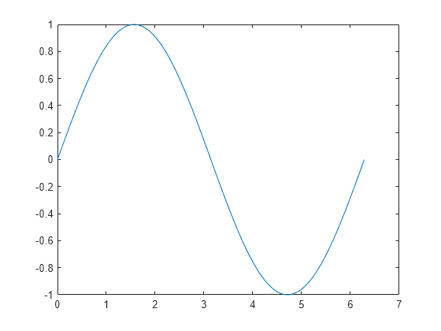

1. **Computing limits**

|  |  |
| --- | --- |
| **Mathematical Operation** | **MATLAB Command** |
| $$\lim_{x→0}{f(x)}$$ | limit(f) |
| $$\lim_{x→a}{f(x)}$$ | limit(f,x,a) or limit(f,a) |
| $$\lim_{x→a-}{f(x)}$$ | limit(f,x,a,’left’) |
| $$\lim_{x→a+}{f(x)}$$ | Limit(f,x,a,’right’) |

**A)Aim:** Write a program to calculate  by using MATLAB

**Program:**

>>syms x;

>> f=(x^2-25)/(x-5);

>> limits[f,5]

**Output:**

f=10

**B)Aim**: Calculate the limit as x approaches 0

**Program:**

$$To find limit of \lim_{x→0}{\frac{x^{2}+1}{3-2x+4x^{2}}}$$

>>syms x;

>>limit( (x^2+1) / (3-2*x + 4*x^2) , inf )

**Output:**

$\frac{1}{4}$

1. **Problems on first order derivatives**

|  |  |
| --- | --- |
| **Mathematical Operation** | **MATLAB Command** |
| $$\frac{df}{dx}$$ | diff(f) or diff( f,x ) |
| $$\frac{df}{da}$$ | diff( f, a ) |
| $$\frac{d^{2}f}{dx^{2}}$$ | Diff( f, x, 2 ) |

1. **Aim:** To find the derivative of f = xn

**Program:**

>> syms x n;

>> f = x^n;

>> Df = diff(f)

>>Df=

**Output:**

n*x^(n - 1)

1. **Aim:** To find the derivative of $f=3t^{2}+2t^{-2}$

**Program:**

>>syms t;

>>f=3*t^2+2*t^(-2);

>>diff(f)

**Output:**

6*t - 4/t^3

**c). Aim:** write a program to find the derivative of 

**Program:**

>>syms x;

>> f = x^3 + 2*x^2 + 3*x + 4;

>>df = diff(f, x);

>>disp(df);

**Output:**

3*x^2+4*x+3

1. **Finding second order derivatives**

**Aim:** To find the derivative of $e^{x}\cos{x}$

**Program:**

>>syms x;

>>g = exp(x)*cos(x);

>>y = diff(g)

**Output:**

e*x* cos(*x*)−e*x* sin(*x*)

>> z = diff(g,2)

**Output:**

z = −2 e*x* sin(*x*)

1. **Finding the indefinite integrals**

**Aim:** Write a program to find the integration of by using MATLAB.

**Program:**

>>syms x;

>>f = x^2;

>> F = int(f, x);

>>disp(F);

**Output:**

x^3/3

1. **Finding the definite integrals**

**Aim:** Write a program to find the  by using MATLAB.

**Program:**

>>syms x;

>>f = x^2;

>> F = int(f, x, 1, 3);

>>disp(F);

**Output:**

26/3